1. Does the project’s Theory of Change specify how it will contribute to higher level change? (Select the option from 1-3 that best reflects the project) | 
 3: The project has a theory of change with explicit assumptions and clear change pathway describing how the project will contribute to outcome level change as specified in the programme/CPD, backed by credible evidence of what works effectively in this context. The project document clearly describes why the project’s strategy is the best approach at this point in time.
 2: The project has a theory of change. It has an explicit change pathway that explains how the project intends to contribute to outcome-level change and why the project strategy is the best approach at this point in time, but is backed by limited evidence.
1: The project does not have a theory of change, but the project document may describe in generic terms how the project will contribute to development results, without specifying the key assumptions. It does not make an explicit link to the programme/CPD’s theory of change.

Evidence (Enter a short explanation or upload a document that provides evidence for your response)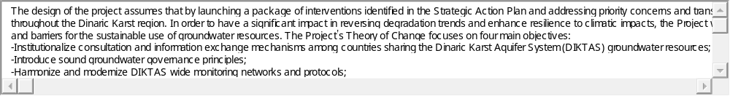

Upload Document
2. Is the project aligned with the thematic focus of the UNDP Strategic Plan? (select the option from 1-3 that best reflects the project)
3: The project responds to one of the three areas of development work as specified in the Strategic Plan; it addresses at least one of the proposed new and emerging areas; an issues-based analysis has been incorporated into the project design; and the project’s RRF includes all the relevant SP output indicators. (all must be true to select this option)
2: The project responds to one of the three areas of development work as specified in the Strategic Plan. The project’s RRF includes at least one SP output indicator, if relevant. (both must be true to select this option)
1: While the project may respond to one of the three areas of development work as specified in the Strategic Plan, it is based on a sectoral approach without addressing the complexity of the development issue. None of the relevant SP indicators are included in the RRF. This answer is also selected if the project does not respond to any of the three areas of development work in the Strategic Plan.

Evidence (Enter a short explanation or upload a document that provides evidence for your response)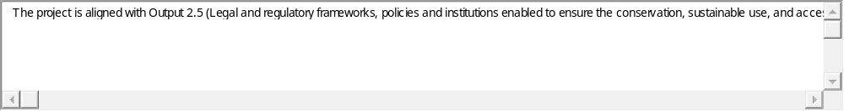

3. Does the project have strategies to effectively identify, engage and ensure the meaningful participation of targeted groups/geographic areas with a priority focus on the excluded and marginalized? (select the option from 1-3 that best reflects this project)
3: The target groups/geographic areas are appropriately specified, prioritising the excluded and/or marginalised. Beneficiaries will be identified through a rigorous process based on evidence (if applicable.)The project has an explicit strategy to identify, engage and ensure the meaningful participation of specified target groups/geographic areas throughout the project, including through monitoring and decision-making (such as representation on the project board) (all must be true to select this option)
2: The target groups/geographic areas are appropriately specified, prioritising the excluded and/or marginalised. The project document states how beneficiaries will be identified, engaged and how meaningful participation will be ensured throughout the project. (both must be true to select this option)
1: The target groups/geographic areas are not specified, or do not prioritize excluded and/or marginalised populations. The project does not have a written strategy to identify or engage or ensure the meaningful participation of the target groups/geographic areas throughout the project.
Not Applicable

Evidence (Enter a short explanation or upload a document that provides evidence for your response)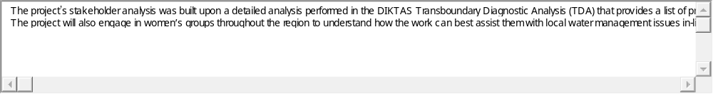

Upload Document
4. Have knowledge, good practices, and past lessons learned of UNDP and others informed the project design? (select the option from 1-3 that best reflects this project)
3: Knowledge and lessons learned (gained e.g. through peer assist sessions) backed by credible evidence from evaluation, corporate policies/strategies, and monitoring have been explicitly used, with appropriate referencing, to develop the project’s theory of change and justify the approach used by the project over alternatives.
2: The project design mentions knowledge and lessons learned backed by evidence/sources, which inform the project’s theory of change but have not been used/are not sufficient to justify the approach selected over alternatives.
1: There is only scant or no mention of knowledge and lessons learned informing the project design. Any references that are made are not backed by evidence.

Evidence (Enter a short explanation or upload a document that provides evidence for your response)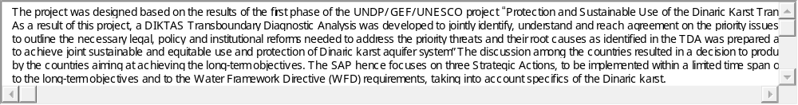

Upload Document
5. Does the project use gender analysis in the project design and does the project respond to this gender analysis with concrete measures to address gender inequities and empower women? (select the option from 1-3 that best reflects this project)
3: A participatory gender analysis on the project has been conducted. This analysis reflects on the different needs, roles and access to/control over resources of women and men, and it is fully integrated into the project document. The project establishes concrete priorities to address gender inequalities in its strategy. The results framework includes outputs and activities that specifically respond to this gender analysis, with indicators that measure and monitor results contributing to gender equality. (all must be true to select this option)
2: A gender analysis on the project has been conducted. This analysis reflects on the different needs, roles and access to/control over resources of women and men. Gender concerns are integrated in the development challenge and strategy sections of the project document. The results framework includes outputs and activities that specifically respond to this gender analysis, with indicators that measure and monitor results contributing to gender equality. (all must be true to select this option)
1: The project design may or may not mention information and/or data on the differential impact of the project’s development situation on gender relations, women and men, but the constraints have not been clearly identified and interventions have not been considered.

Evidence (Enter a short explanation or upload a document that provides evidence for your response)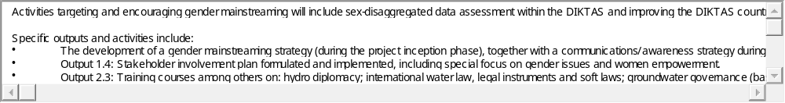

Upload Document
6. Does UNDP have a clear advantage to engage in the role envisioned by the project vis-à-vis national partners, other development partners, and other actors? (select the option from 1-3 that best reflects this project)
3: An analysis has been conducted on the role of other partners in the area where the project intends to work, and credible evidence supports the proposed engagement of UNDP and partners through the project. It is clear how results achieved by relevant partners will contribute to outcome level change complementing the project’s intended results. If relevant, options for south-south and triangular cooperation have been considered, as appropriate. (all must be true to select this option)
2: Some analysis has been conducted on the role of other partners where the project intends to work, and relatively limited evidence supports the proposed engagement of and division of labour between UNDP and partners through the project. Options for south-south and triangular cooperation may not have not been fully developed during project design, even if relevant opportunities have been identified.
1: No clear analysis has been conducted on the role of other partners in the area that the project intends to work, and relatively limited evidence supports the proposed engagement of UNDP and partners through the project. There is risk that the project overlaps and/or does not coordinate with partners’ interventions in this area. Options for south-south and triangular cooperation have not been considered, despite its potential relevance.

Evidence (Enter a short explanation or upload a document that provides evidence for your response)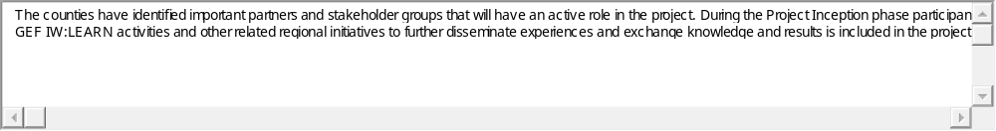

Upload Document
7. Does the project seek to further the realization of human rights using a human rights based approach? (select from options 1-3 that best reflects this project)
3: Credible evidence that the project aims to further the realization of human rights, upholding the relevant international and national laws and standards in the area of the project. Any potential adverse impacts on enjoyment of human rights were rigorously identified and assessed as relevant, with appropriate mitigation and management measures incorporated into project design and budget. (all must be true to select this option)
2: Some evidence that the project aims to further the realization of human rights. Potential adverse impacts on enjoyment of human rights were identified and assessed as relevant, and appropriate mitigation and management measures incorporated into the project design and budget.
1: No evidence that the project aims to further the realization of human rights. Limited or no evidence that potential adverse impacts on enjoyment of human rights were considered.

Evidence (Enter a short explanation or upload a document that provides evidence for your response)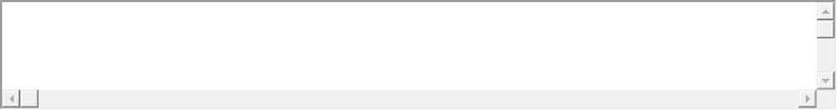

Upload Document
8. Did the project consider potential environmental opportunities and adverse impacts, applying a precautionary approach? (select from options 1-3 that best reflects this project)
3: Credible evidence that opportunities to enhance environmental sustainability and integrate poverty-environment linkages were fully considered as relevant, and integrated in project strategy and design. Credible evidence that potential adverse environmental impacts have been identified and rigorously assessed with appropriate management and mitigation measures incorporated into project design and budget. (all must be true to select this option).
2: No evidence that opportunities to strengthen environmental sustainability and poverty-environment linkages were considered. Credible evidence that potential adverse environmental impacts have been identified and assessed, if relevant, and appropriate management and mitigation measures incorporated into project design and budget.
1: No evidence that opportunities to strengthen environmental sustainability and poverty-environment linkages were considered. Limited or no evidence that potential adverse environmental impacts were adequately considered.

Evidence (Enter a short explanation or upload a document that provides evidence for your response)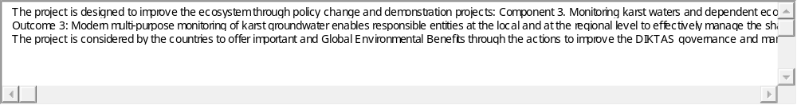

Upload Document
9. Has the Social and Environmental Screening Procedure (SESP) been conducted to identify potential social and environmental impacts and risks? [If yes, upload the completed checklist as evidence. If SESP is not required, provide the reason(s) for the exemption in the evidence section. Exemptions include the following:
- Preparation and dissemination of reports, documents and communication materials
- Organization of an event, workshop, training
- Strengthening capacities of partners to participate in international negotiations and conferences
- Partnership coordination (including UN coordination) and management of networks
- Global/regional projects with no country level activities (e.g. knowledge management, inter-governmental processes)
- UNDP acting as Administrative Agent
Yes
No
SESP not required

Evidence (Enter a short explanation or upload a document that provides evidence for your response)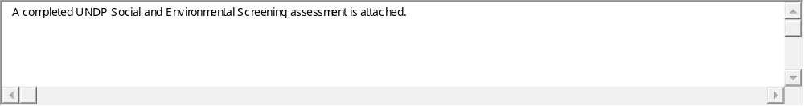

Upload Document
10. Does the project have a strong results framework? (select from options 1-3 that best reflects this project)
3: The project’s selection of outputs and activities are at an appropriate level and relate in a clear way to the project’s theory of change. Outputs are accompanied by SMART, results-oriented indicators that measure all of the key expected changes identified in the theory of change, each with credible data sources, and populated baselines and targets, including gender sensitive, sex-disaggregated indicators where appropriate. (all must be true to select this option)
2: The project’s selection of outputs and activities are at an appropriate level, but may not cover all aspects of the project’s theory of change. Outputs are accompanied by SMART, results-oriented indicators, but baselines, targets and data sources may not yet be fully specified. Some use of gender sensitive, sex-disaggregated indicators, as appropriate. (all must be true to select this option)
1: The results framework does not meet all of the conditions specified in selection “2” above. This includes: the project’s selection of outputs and activities are not at an appropriate level and do not relate in a clear way to the project’s theory of change; outputs are not accompanied by SMART, results-oriented indicators that measure the expected change, and have not been populated with baselines and targets; data sources are not specified, and/or no gender sensitive, sex-disaggregation of indicators.

Evidence (Enter a short explanation or upload a document that provides evidence for your response)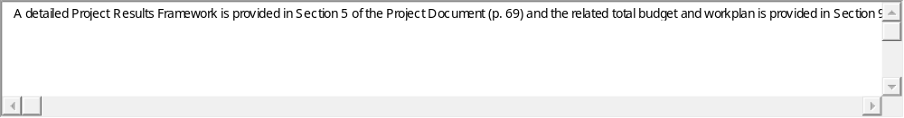

Upload Document
11. Is there a comprehensive and costed M&E plan with specified data collection sources and methods to support evidence-based management, monitoring and evaluation of the project?
Yes
No

Evidence (Enter a short explanation or upload a document that provides evidence for your response)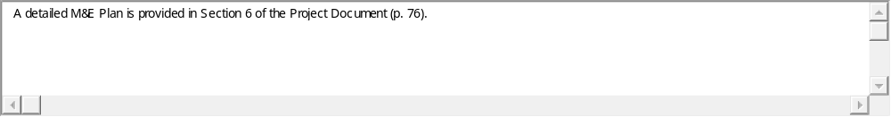

Upload Document
12. Is the project’s governance mechanism clearly defined in the project document, including planned composition of the project board? (select from options 1-3 that best reflects this project)
3: The project’s governance mechanism is fully defined in the project document. Individuals have been specified for each position in the governance mechanism (especially all members of the project board.) Project Board members have agreed on their roles and responsibilities as specified in the terms of reference. The ToR of the project board has been attached to the project document. (all must be true to select this option).
2: The project’s governance mechanism is defined in the project document; specific institutions are noted as holding key governance roles, but individuals may not have been specified yet. The prodoc lists the most important responsibilities of the project board, project director/manager and quality assurance roles. (all must be true to select this option)
1: The project’s governance mechanism is loosely defined in the project document, only mentioning key roles that will need to be filled at a later date. No information on the responsibilities of key positions in the governance mechanism is provided.

Evidence (Enter a short explanation or upload a document that provides evidence for your response)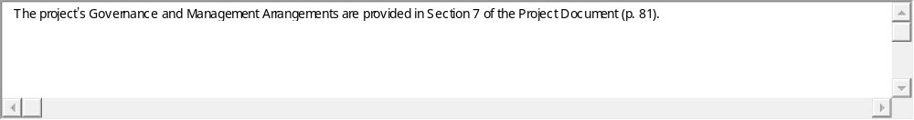

Upload Document
13. Have the project risks been identified with clear plans stated to manage and mitigate each risks? (select from options 1-3 that best reflects this project)
3: Project risks related to the achievement of results are fully described in the project risk log, based on comprehensive analysis drawing on the theory of change, Social and Environmental Standards and screening, situation analysis, capacity assessments and other analysis. Clear and complete plan in place to manage and mitigate each risk. (both must be true to select this option)
2: Project risks related to the achievement of results identified in the initial project risk log with mitigation measures identified for each risk.
1: Some risks may be identified in the initial project risk log, but no evidence of analysis and no clear risk mitigation measures identified. This option is also selected if risks are not clearly identified and no initial risk log is included with the project document.

Evidence (Enter a short explanation or upload a document that provides evidence for your response)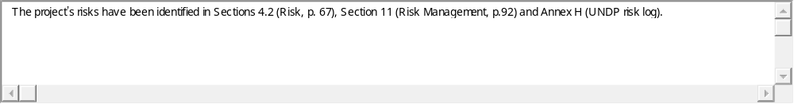

Upload Document
14. Have specific measures for ensuring cost-efficient use of resources been explicitly mentioned as part of the project design? This can include: i) using the theory of change analysis to explore different options of achieving the maximum results with the resources available; ii) using a portfolio management approach to improve cost effectiveness through synergies with other interventions; iii) through joint operations (e.g., monitoring or procurement) with other partners.
Yes
No

Evidence (Enter a short explanation or upload a document that provides evidence for your response)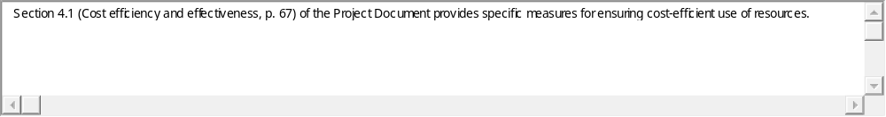

Upload Document
15. Are explicit plans in place to ensure the project links up with other relevant on-going projects and initiatives, whether led by UNDP, national or other partners, to achieve more efficient results (including, for example, through sharing resources or coordinating delivery?)
Yes
No

Evidence (Enter a short explanation or upload a document that provides evidence for your response)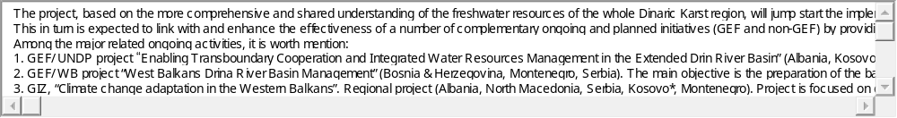

Upload Document
16. Is the budget justified and supported with valid estimates?
3: The project’s budget is at the activity level with funding sources, and is specified for the duration of the project period in a multi-year budget. Costs are supported with valid estimates using benchmarks from similar projects or activities. Cost implications from inflation and foreign exchange exposure have been estimated and incorporated in the budget.
2: The project’s budget is at the activity level with funding sources, when possible, and is specified for the duration of the project in a multi-year budget. Costs are supported with valid estimates based on prevailing rates.
1: The project’s budget is not specified at the activity level, and/or may not be captured in a multi-year budget.

Evidence (Enter a short explanation or upload a document that provides evidence for your response)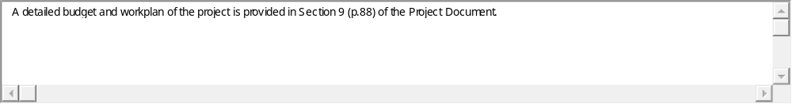

Upload Document
17. Is the Country Office fully recovering the costs involved with project implementation?
3: The budget fully covers all project costs that are attributable to the project, including programme management and development effectiveness services related to strategic country programme planning, quality assurance, pipeline development, policy advocacy services, finance, procurement, human resources, administration, issuance of contracts, security, travel, assets, general services, information and communications based on full costing in accordance with prevailing UNDP policies (i.e., UPL, LPL.)
2: The budget covers significant project costs that are attributable to the project based on prevailing UNDP policies (i.e., UPL, LPL) as relevant.
1: The budget does not reimburse UNDP for direct project costs. UNDP is cross-subsidizing the project and the office should advocate for the inclusion of DPC in any project budget revisions.

Evidence (Enter a short explanation or upload a document that provides evidence for your response)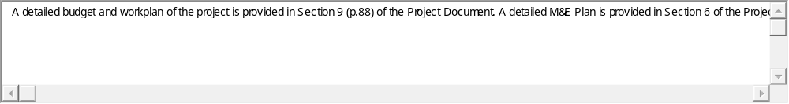

Upload Document
EffectiveQuality Rating:
Sustainability & National Ownership Quality Rating:
Quality Assurance Summary/LPAC Comments

Upload Document
18. Is the chosen implementation modality most appropriate? (select from options 1-3 that best reflects this project)
3: The required implementing partner assessments (capacity assessment, HACT micro assessment) have been conducted, and there is evidence that options for implementation modalities have been thoroughly considered. There is a strong justification for choosing the selected modality, based on the development context. (both must be true to select this option)
2: The required implementing partner assessments (capacity assessment, HACT micro assessment) have been conducted and the implementation modality chosen is consistent with the results of the assessments.
1: The required assessments have not been conducted, but there may be evidence that options for implementation modalities have been considered.

Evidence (Enter a short explanation or upload a document that provides evidence for your response)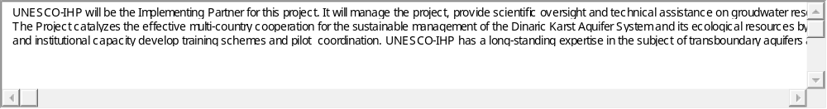

Upload Document
19. Have targeted groups, prioritizing marginalized and excluded populations that will be affected by the project, been engaged in the design of the project in a way that addresses any underlying causes of exclusion and discrimination?
3: Credible evidence that all targeted groups, prioritising marginalized and excluded populations that will be involved in or affected by the project, have been actively engaged in the design of the project. Their views, rights and any constraints have been analysed and incorporated into the root cause analysis of the theory of change which seeks to address any underlying causes of exclusion and discrimination and the selection of project interventions.
2: Some evidence that key targeted groups, prioritising marginalized and excluded populations that will be involved in the project, have been engaged in the design of the project. Some evidence that their views, rights and any constraints have been analysed and incorporated into the root cause analysis of the theory of change and the selection of project interventions.
1: No evidence of engagement with marginalized and excluded populations that will be involved in the project during project design. No evidence that the views, rights and constraints of populations have been incorporated into the project.
Not Applicable

Evidence (Enter a short explanation or upload a document that provides evidence for your response)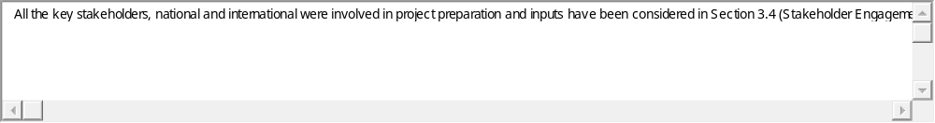

Upload Document
20. Does the project conduct regular monitoring activities, have explicit plans for evaluation, and include other lesson learning (e.g. through After Action Reviews or Lessons Learned Workshops), timed to inform course corrections if needed during project implementation?
Yes
No

Evidence (Enter a short explanation or upload a document that provides evidence for your response)

Upload Document
21. The gender marker for all project outputs are scored at GEN2 or GEN3, indicating that gender has been fully mainstreamed into all project outputs at a minimum.
Yes
No

Evidence (Enter a short explanation or upload a document that provides evidence for your response)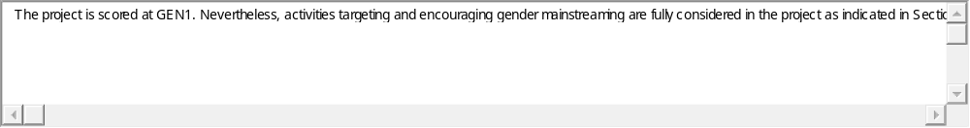

Upload Document
22. Is there a realistic multi-year work plan and budget to ensure outputs are delivered on time and within allotted resources? (select from options 1-3 that best reflects this project)
3: The project has a realistic work plan & budget covering the duration of the project at the activity level to ensure outputs are delivered on time and within the allotted resources.
2: The project has a work plan & budget covering the duration of the project at the output level.
1: The project does not yet have a work plan & budget covering the duration of the project.

Evidence (Enter a short explanation or upload a document that provides evidence for your response)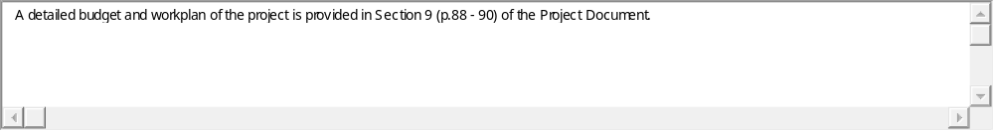

Upload Document
23. Have national partners led, or proactively engaged in, the design of the project?
3: National partners have full ownership of the project and led the process of the development of the project jointly with UNDP.
2: The project has been developed by UNDP in close consultation with national partners.
1: The project has been developed by UNDP with limited or no engagement with national partners.
Not Applicable

Evidence (Enter a short explanation or upload a document that provides evidence for your response)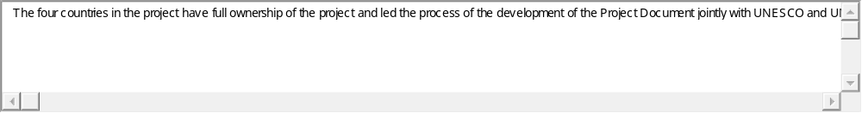

Upload Document
24. Are key institutions and systems identified, and is there a strategy for strengthening specific/ comprehensive capacities based on capacity assessments conducted? (select from options 0-4 that best reflects this project):
3: The project has a comprehensive strategy for strengthening specific capacities of national institutions based on a systematic and detailed capacity assessment that has been completed. This strategy includes an approach to regularly monitor national capacities using clear indicators and rigorous methods of data collection, and adjust the strategy to strengthen national capacities accordingly.
2.5: A capacity assessment has been completed. The project document has identified activities that will be undertaken to strengthen capacity of national institutions, but these activities are not part of a comprehensive strategy to monitor and strengthen national capacities.
2: A capacity assessment is planned after the start of the project. There are plans to develop a strategy to strengthen specific capacities of national institutions based on the results of the capacity assessment.
1.5: There is mention in the project document of capacities of national institutions to be strengthened through the project, but no capacity assessments or specific strategy development are planned.
1: Capacity assessments have not been carried out and are not foreseen. There is no strategy for strengthening specific capacities of national institutions.
Not Applicable

Evidence (Enter a short explanation or upload a document that provides evidence for your response)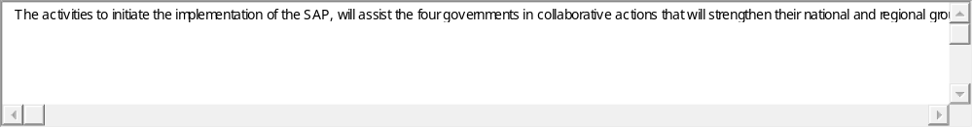

Upload Document
25. Is there is a clear strategy embedded in the project specifying how the project will use national systems (i.e., procurement, monitoring, evaluations, etc.,) to the extent possible?
Yes
No
Not Applicable

Evidence (Enter a short explanation or upload a document that provides evidence for your response)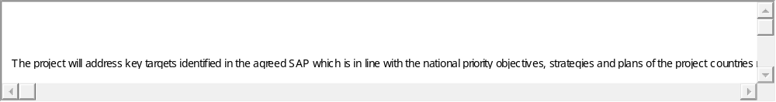

Upload Document
26. Is there a clear transition arrangement/ phase-out plan developed with key stakeholders in order to sustain or scale up results (including resource mobilisation strategy)?
Yes
No

Evidence (Enter a short explanation or upload a document that provides evidence for your response)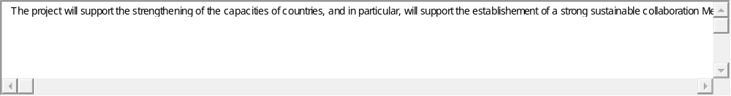

Upload Document

